Chapter 8 Lesson 1 Exit Slip
Create a table to represent this situation. Gina is 5 years older than Sam. Gina’s age, in years, is x + 5, where x is Sam’s age, in years. See students’ work.

Chapter 8 Lesson 2 Exit Slip
Find the value of the tenth position.
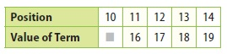

Chapter 8 Lesson 3 Exit Slip
Describe the procedures you would use to graph y = x + 3. Then graph it on the coordinate plane. Graph 4 ordered pairs.
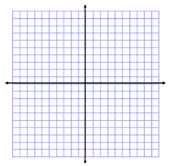

Chapter 8 Lesson 4 Exit Slip
Describe how the concepts in earlier lessons on tables, rules, graphs, and equations helped with this lesson on multiple representations of functions. Use the following writing prompts.
- In this lesson, I learned ______________________________________________
_________________________________________________________________.
- In the next lesson, I will learn _________________________________________
_________________________________________________________________.
- What I learned in previous lessons helped me with the concepts in this lesson because __________________________________________________________
_________________________________________________________________.
Chapter 8 Lesson 5 Exit Slip
Determine which of the values 11, 12, or 13 make the inequality x + 5 < 17 true.

Chapter 8 Lesson 6 Exit Slip
Write an inequality to represent the following situation.
Marcus is at least 68 inches tall.

Chapter 8 Lesson 7 Exit Slip
Describe the procedure you would use to solve 3x < 39. Then solve the inequality.

