Chapter 5 Lesson 1 Exit Slip
Write a positive integer and a negative integer and graph each on a number line.
Positive Integer: _________ Negative Integer: __________

Chapter 5 Lesson 2 Exit Slip
Show how you would evaluate the expression |−3| + |5|.

Chapter 5 Lesson 3 Exit Slip
Lisa has taken 50 cents out of her piggy bank. Claire has put 35 cents in her piggy bank. Dean has taken 25 cents out of his piggy bank. Explain how you would compare and order the amounts from least to greatest.

Chapter 5 Lesson 4 Exit Slip
Express as a decimal.
 |  | A. | 0.26 | B. | 3.6666…
 |  | C. | 2.6 | D. | 26

Chapter 5 Lesson 5 Exit Slip
Write a set of rational numbers that are in order from least to greatest. The list should contain at least one terminating decimal, at least one fraction, and at least two negative numbers.

Chapter 5 Lesson 6 Exit Slip
Name the ordered pair that is a reflection of (5, −4) across they-axis.
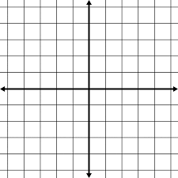
Chapter 5 Lesson 7 Exit Slip
Describe how you would graph (−3, −2) on a coordinate plane.
-From the Origin________________________________________________________________
____________________________________________________________________________.

Then Plot (-3, -2), label the X & Y Axis on the coordinate plane.

