Chapter 12 Lesson 1 Exit Slip
Use the line plot to find the median.
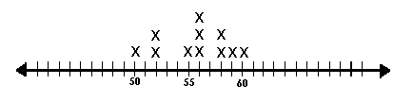

Chapter 12 Lesson 2 Exit Slip
$2.79, $2.56, $1.99, $3.20, $2.95, $1.40, $2.75, $4.19, and $3.64
Write the intervals you would use to create a histogram of these prices.

Chapter 12 Lesson 3 Exit Slip
Write how the earlier lesson on measures of variation helped you with this lesson on box plots. Use the writing prompts below.
- In the earlier lesson on measures of variation, I learned_________________
______________________________________________________________________________________________________________.
- In this lesson, I learned_______________________________________
______________________________________________________________________________________________________________.
- What I learned in the earlier lesson helped me with today's lesson because_____
______________________________________________________________________________________________________________.

