Chapter 11 Lesson 1 Exit Slip
Mary Jo wants to find the average of her friend's weekly allowances.
Use the table below, and find the mean weekly allowance.
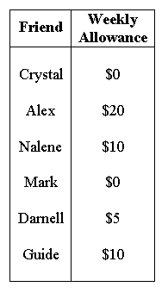
Chapter 11 Lesson 2 Exit Slip
Find the median and mode of the data set: 12, 14, 15, 16, 17, 17, 18, and 21.

Chapter 11 Lesson 3 Exit Slip
Find the measures of variation for the data set: 1, 1, 2, 3, 3, 5, 7, 9. SHOW ALL WORK!
Range:_____ Median:_____ 1st Quartile:_____ 3rd Quartile:_____ Interquartile Range:_____

Chapter 11 Lesson 4 Exit Slip
Find the mean absolute deviation for the data in the table.
Round to the nearest tenth if necessary. SHOW ALL WORK!
